**Programming Language Concept-Assigment-1**

**SCS 2110**

**16001281**

**A.A.Sathsarani**

<Flow Chart>::<start><contain><end>

<start>::

<input>

<contain >:: < contain > < contain > |

<process>

<condition>

< input>:: <String>=<Signed Integer> |<String>{<String>|<digit>}=<String>{< String >} | < String >{< String >|<digit>}=<Signed Integer>.<Integer>

<process >:: < String ><action>|< String >=<action>|< String >

<condition >:: if <Expression>

<Expression>:: < String >< Logic_Operater >< String >{<Operator><Expression>}| < String >< Logic_Operater ><Signed Integer >{<Operator><Expression>}| < String > < Logic_Operater > <Signed Integer>.<Integer>{<Operator> <Expression>}| <Signed Integer><Logic>< String >{<Operator><Expression>}|<Signed Integer>< Logic_Operater ><Signed Integer >{<Operator><Expression>}| <Signed Integer> <Logic> <Signed Integer> . <Integer> { <Operator> <Expression> } | <Signed Integer> . <Integer> <Logic_Operater> <Signed Integer> . <Integer> { <Operator> <Expression> } | <Signed Integer> . <Integer> < Logic_Operater ><Signed Integer >{<Operator> <Expression>} |<Signed Integer> . <Integer> < Logic_Operater >< String > { <Operator> <Expression> }

<Logic_Operater>:: >|<|<=|>=|==|!=

<Operator> :: AND|OR|NOT|XOR

<String>:: A|B|C|..|Z|a|b|c|...|z {< String >|<digit>}

<Signed Integer>:: <Integer>|-<Integer>

<Integer>::<Integer><digit>|<Integer>

<digit>::0|1|2|3|4|5|6|7|8|9

<action>:: < String >+< String >|+< String ><action> | +<Signed Integer>|+<Signed Integer><action> | +<Signed Integer>.<Integer>|+<Signed Integer>.<Integer><action> | -< String >|-< String ><action> | -<Signed Integer>|-<Signed Integer><action> | -<Signed Integer>.<Integer>|-<Signed Integer>.<Integer><action> | *< String >|*< String ><action> | *<Signed Integer>|*<Signed Integer><action> | *<Signed Integer>.<Integer>|*<Signed Integer>.<Integer><action> | /< String >|/< String ><action> |/<Signed Integer>/<Signed

Integer><action> |/<Signed Integer>.<Integer>|/<Signed Integer>.<Integer><action> | %< String >|%< String ><action> | %<Signed Integer>|%<Signed Integer><action> | %<Signed Integer>.<Integer>|%<Signed Integer>.<Integer><action>

<end> ::

Example

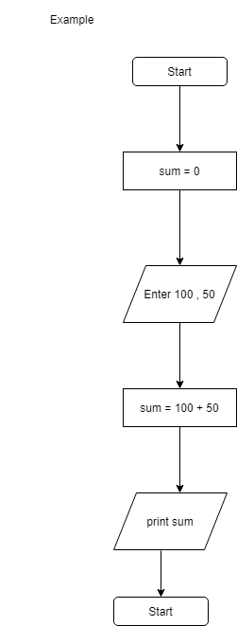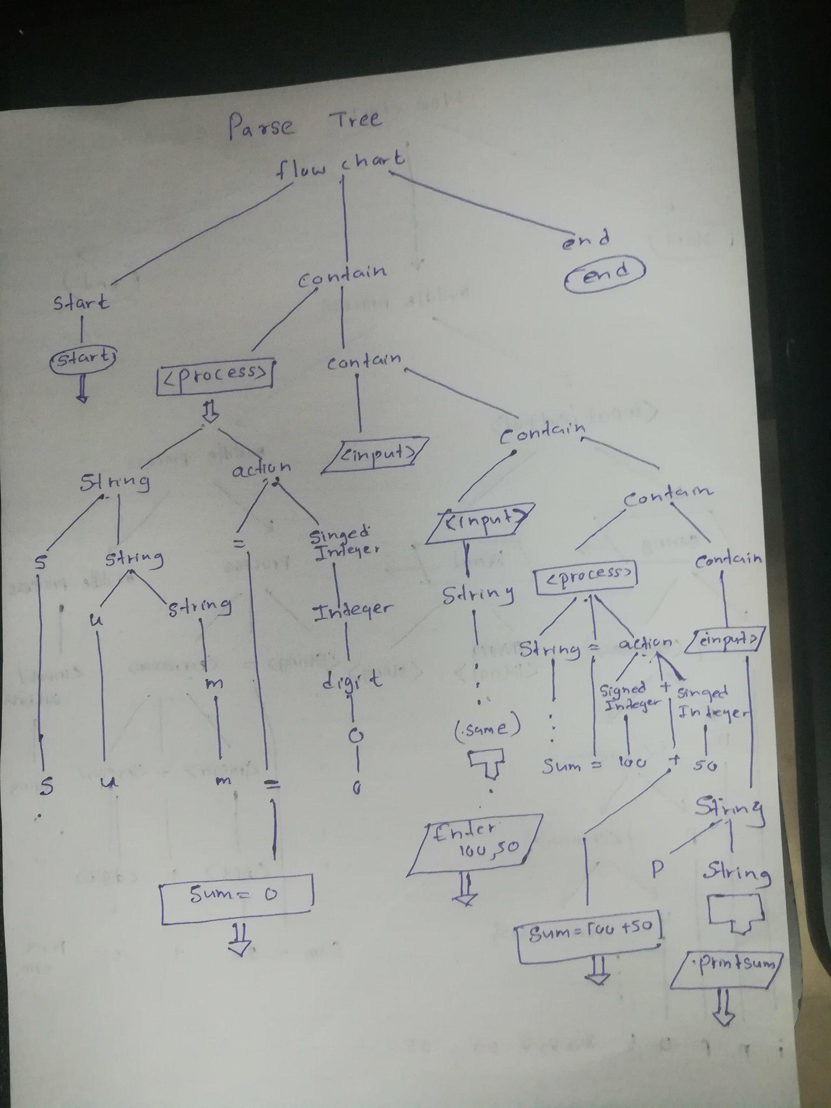

We can Get

